## Homework 6_1

#### Problem 1:

1. **Slope = -3**
2. **Slope = 9**

#### Problem 2:

1. **Slope = 5**
2. **Slope = 0**
3. **Slope = -10**
4. **Slope = 0**
5. **Slope = -10**
6. **Slope = 0**
7. **Slope = 5**

#### Problem 3:

1. $Δ$**y = = 0.002499**
2. ${0.002499}/{0.01}$**= 0.2499**
3.**= 1/4**

#### Problem 4:

1. **y’(5) = cos(5) − (5) sin(5) = 5.078**

#### Problem 5:

1. **y’(5) = sin(2(5)^2)+4(5)^2 * cos(2(5)^2) = 96.23**

#### Problem 6:

1. **y’(0.5) =**  **-((0.5) * sin((0.5)) + cos((0.5)) )/ (0.5)^2 = -4.469**

#### Problem 7:

1. **y’(0.1) =**  **−(2(0.1)^2−1)e^(−(0.1)^2) = 0.9702**

#### Problem 8:

1. **y’’(5) = −2sin(5)−(5)cos(5) = 0.4995**

#### Problem 9:

1. **-3**
2. **y(-3) = -2*(-3)^3 - 3*(-3)^2 + 36*(-3) - 12 = - 93**
3. **2**
4. **y(2) = -2*(2)^3 - 3*(2)^2 + 36*(2) - 12 = 32**

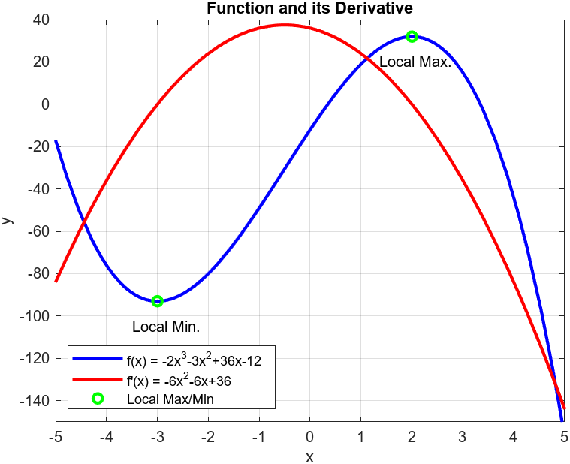

#### Problem 10:

1. **y(1) = -10*(1) + 100*(1-e^(-2(1))) = 76.47**
2. **y’(1) = -10 + 200*(e^(-2(1))) = 17.07**
3. **y’(1) = -400*(e^(-2(1))) = -54.13**

